**National Rivers and Stream Assessment Fish Assemblage Quality Assurance Procedure 2023-2024 (Draft)**

**Darin Kopp, Richard Mitchell, Louis Reynolds, and Dave Peck**

**Background:** Fish assemblages are a key indicator of biological integrity and water quality surveyed by the National Rivers and Streams Assessment. Technical Reports and Field and Laboratory Manuals provide critical details about how these data are collected. This document and associated scripts outline the QA/QC procedure used to ensure the data reported by field crews are of the highest quality for use in biological assessment. This is a semi-automated procedure with three modules that efficiently identifies and corrects inconsistencies or errors in the data (Figure 1).

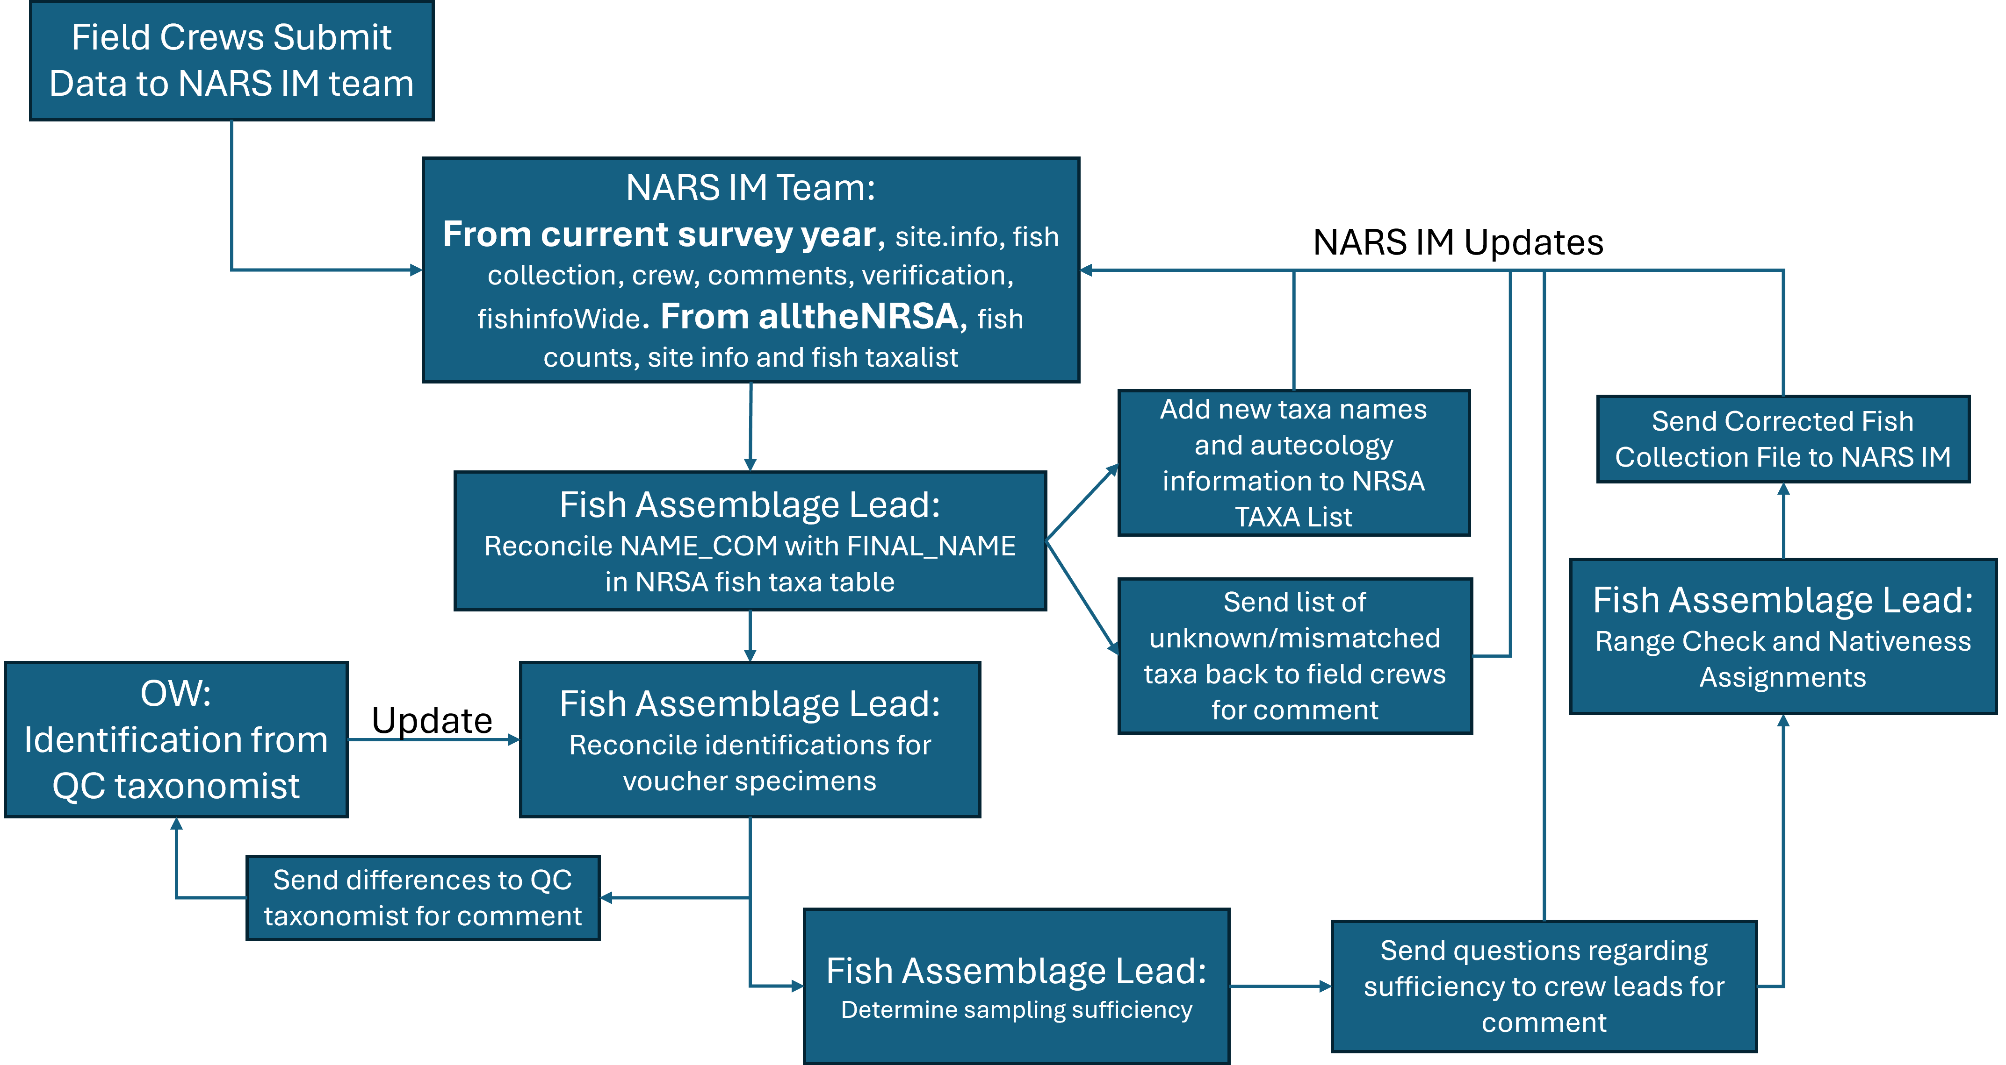

**Figure 1: Schematic of QA procedure.**

**Name Reconciliation:** The name reconciliation module harmonizes field identifications with the NRSA taxa list. Any identifications that were unknown or not easily reconciled were sent to the field crew for comment. If the field crew indicated that updates were made, corrections are added to NARS IM. Any taxa that were not collected during a previous survey are added to the NRSA taxa list along with their autecology information.

**Sampling sufficiency:** The sampling sufficiency module ensures that sampling efforts were consistent with the protocol outlined in the Field Manual such that the sampled assemblage is representative of the entire community. The categories used are consistent with previous surveys and balances input from field crew, total reach length, reach length fished and number of individuals collected. Instances where there was disagreement between the assignment and the value (Y/N) reported by the crews were checked manually.

**Range and Nativeness Checks:** The range and nativeness checks determine whether a specimen identified in the field was consistent with its known range and assigned native/nonnative status for each species at the HUC8 level. This module first created a table from NAS, NATURESERVE and previous NRSA surveys containing all species occurrences and HUC8 combinations and the native/nonnative status. The script then iteratively compared each 2324 occurrence to the table leveraging nested hydrologic unit codes. Any 2324 occurrences that could not be matched to the nativeness table were manually checked using all available resources.